

Deploy Static Website on AWS

1. 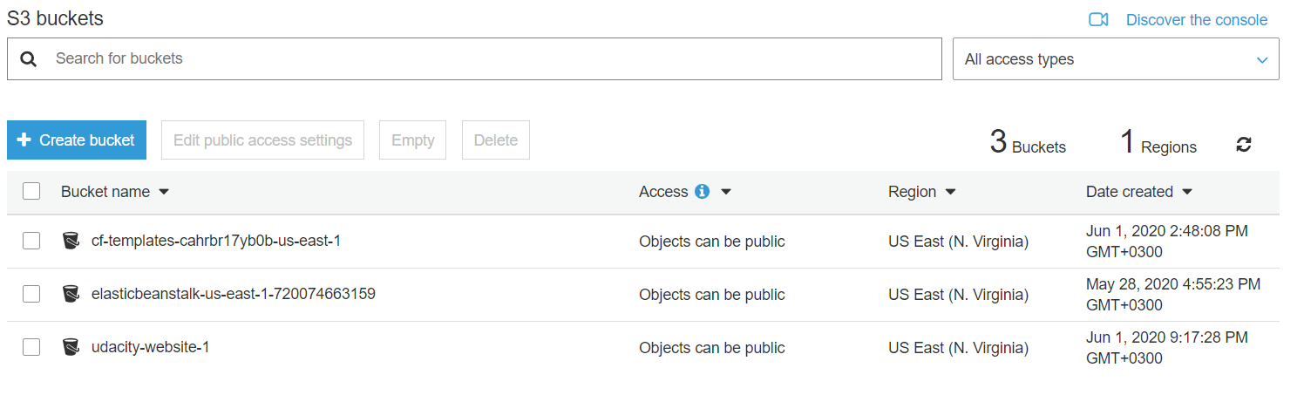Create S3 Bucket:
2. 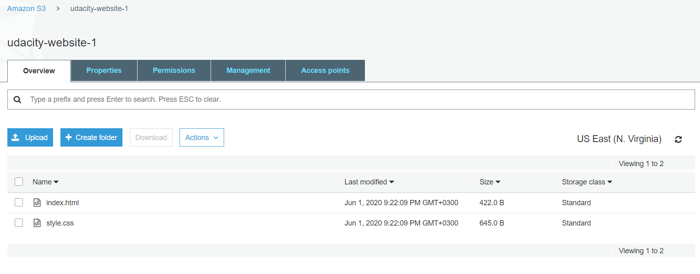Upload files to S3 Bucket:
3. 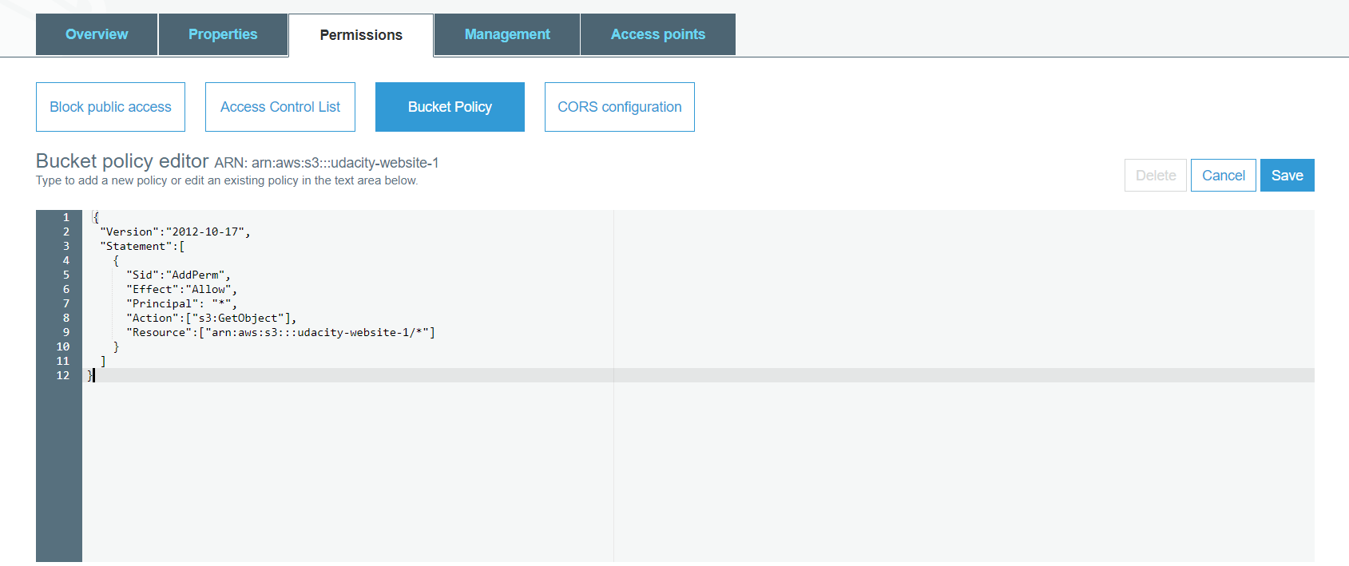Secure Bucket via IAM:
4. Configure S3 Bucket:

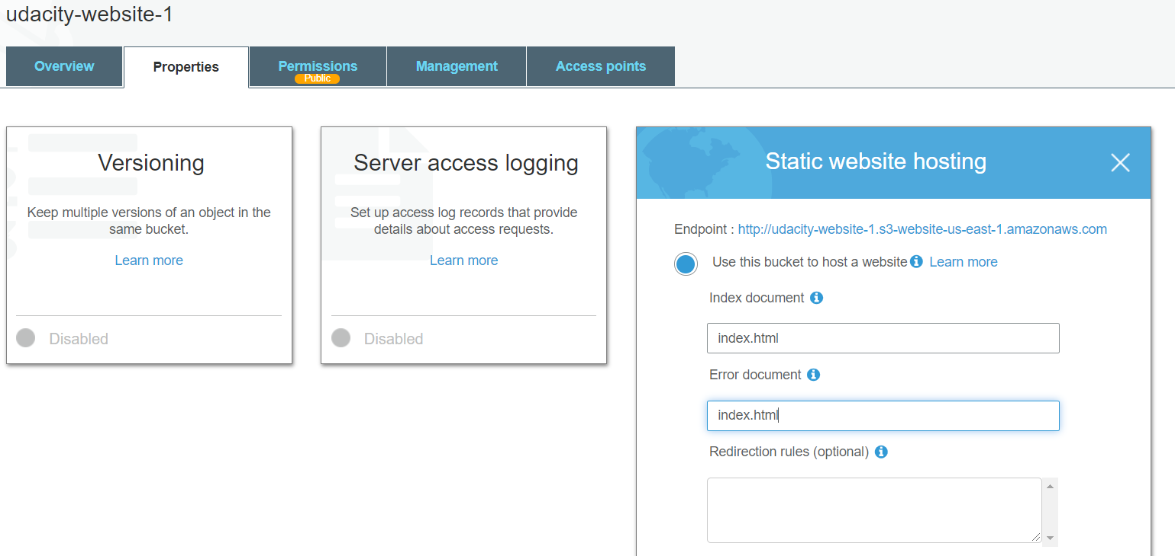

1. Distribute Website via CloudFront:

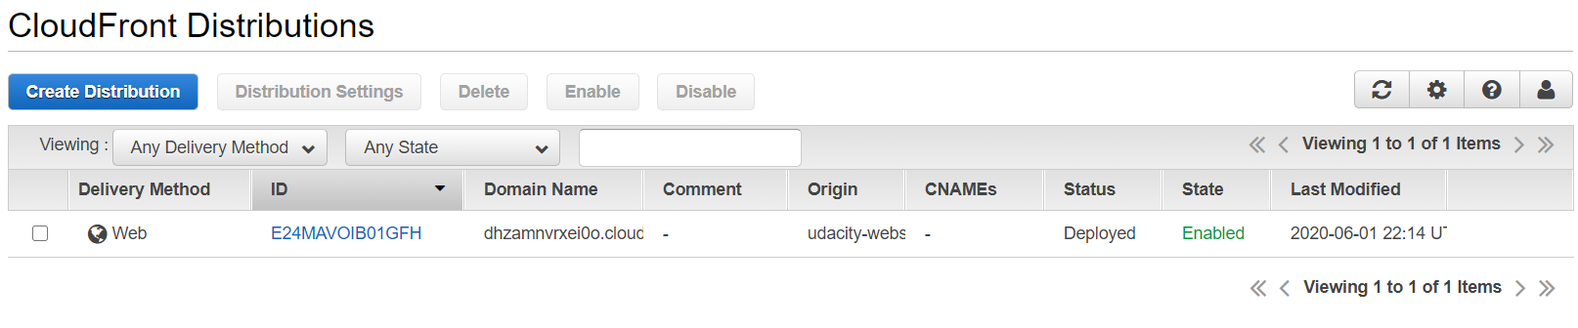

1. Include the Website URL in README.txt file: **Done.**
2. Access Website in Web Browser: **Successful.**